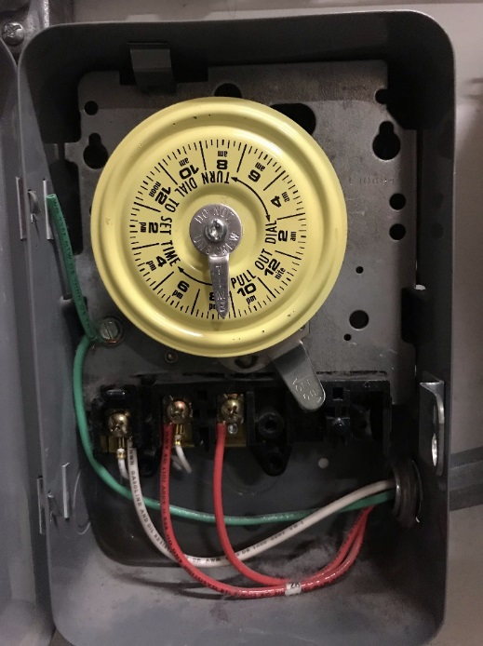There are two basic types of timers. Digital and Mechanical.

A mechanical device that has a large wheel that rotates.

As the wheel spins, there is a lever inside that clicks over.

At 9:00 AM the lights come on, at 9:00 PM the lights go off.

The ‘pins’ can be set for almost any time.

Digital is an electronic timer doing the same sort of timing and turning off and on. Most alarm clocks are digital these days.

MECHANICAL :

If you get a call for a timer without any pins, be very suspect that the timer has failed and that the timer will need to be replaced.

The removal of the pins is a conscious act and the person doing this would have a reason.

If the motor is failing, and the unit is not turning the lights off and on properly, then the store personal might remove the pins to get the lights to stay on.

No pins is a warning that there is a problem. If you supply and install pins, the timer might fail and cause a warranty issue. It would be better to alert corporate that we put in pins, but…. If there is a problem, we will need to replace the timer.

GET THE INFORMMATION !!!! PHOTOS, MAKE, MODEL, ETC, if it fails we need to act fast and we should not charge a second trip to get informant that should have been gotten on the first call.

**NUMBER OF CIRCUITS :**

More important for electrical reasons, the second required information is how many circuits.

A timer can control multiple circuits, we typically only see 1 or 2 circuits, but at times, there are timers that do up to 4 circuits.

If more than 4 circuits, it is often better to use a single channel timer and a Lighting Contactor.

A typical circuit might be the front sign and the front soffit lights.

PHOTOS ARE REQUIRED.

The more circuits, the more expensive. 1 circuit, could cost under $150, 2 circuits, under $200, but 4 circuits might be $400-$500 because they are uncommon.

**ASTRONOMICAL :**

These astronomical lighting controls automatically adjust daily for changing sunrise and sunset times, eliminating the need for separate photocontrol devices. Each features an ethernet port to allow remote programming via PC, and a built-in supercapacitor to maintain programming during power outages.

Astronomical timers are NOT used in a Mall. These times are expensive and the only real claim they have is that the timing program can be done on a memory stick and then uploaded.

The idea is that corporate can say that the store sign will come on at 8:00 AM and stay on till 11:00 PM

**SALES FLOOR LIGHTS :**

If a timer is controlling the sales floor lights, and they are set for 9:55 AM to 10:30 PM, then for most of the year, things are great.

If the store is open at 6:00 AM and closes at midnight on Black Friday, the lights might go off before closing and effect sales. There are two ways to get around this.

#1) install a timer bypass. This is a simple light switch. The store takes control if they have a switch.

#2) use an Astronomical timer, program in the on and off times for every day of the year. Some digital timers have 4,000 off/on times a year.

Typically the mall or landlord requires the store sign to come on at a certain time of the day and go off after a certain time of the night. This way, the shopping center looks more alive between those times.

Part of our work is to show the manager how to set the time. In case the mall requires it, or in case Day Light Savings Time changes.

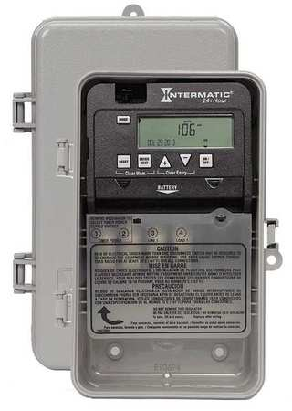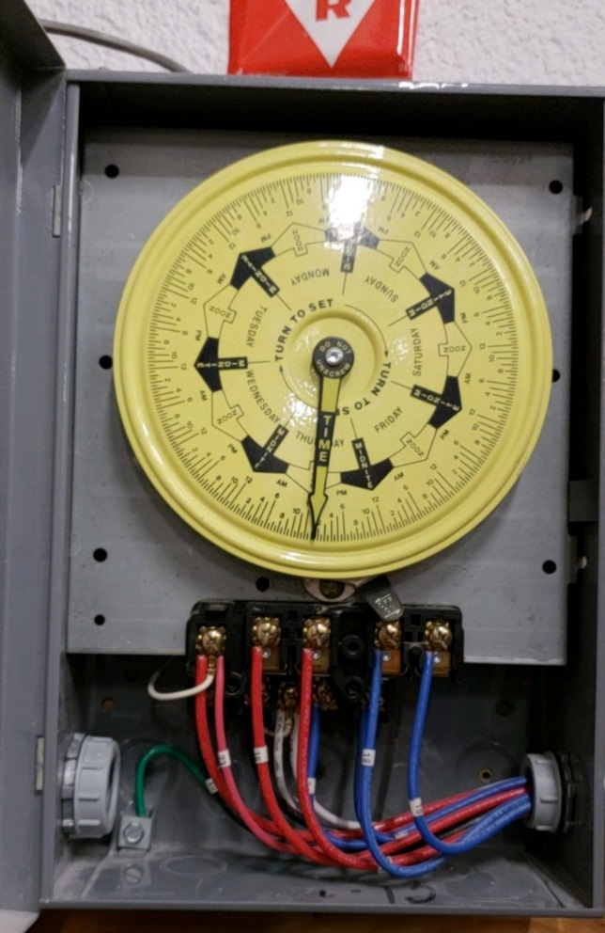

**CSR check list**

PHOTO of the breaker panel area is needed.

If there are more than 1 timer, please verify what each timer controls.

PHOTO of the timer with the door open is needed.

For replacement, we should verify the exact same make and model if possible.

If the existing is a 4 channel, but they only use 2 channels, then a 2 channel is an acceptable alternative.

We always want to move to Digital if we can. Much preferred.

If a replacement is required, can the tech offer additional cost to S/I a bypass switch also?

**TECH CHECK LIST :**

Photo of entire electric panel area

Advise number of timers

Advise make and model of unit having problems,

Make

Model

# of circuits

Dial or Digital

Cost to supply Like-for-Like with matching unit ?

With bypass